Packet Size- 128:
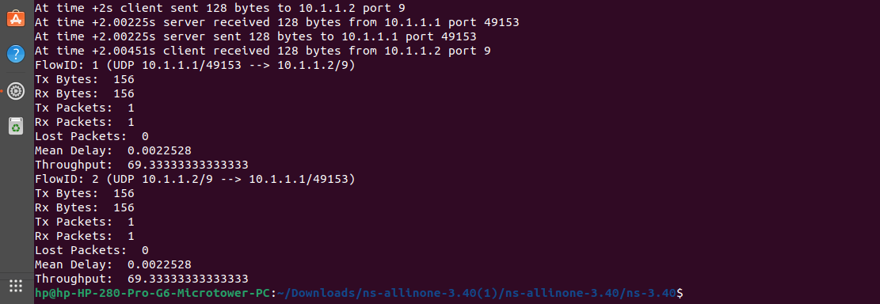

Packet Size- 256:
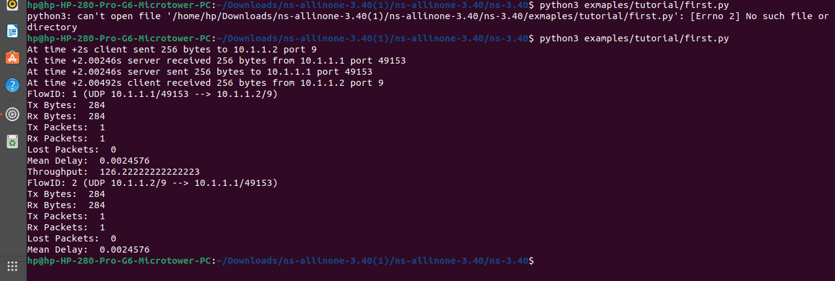

Packet Size- 512:
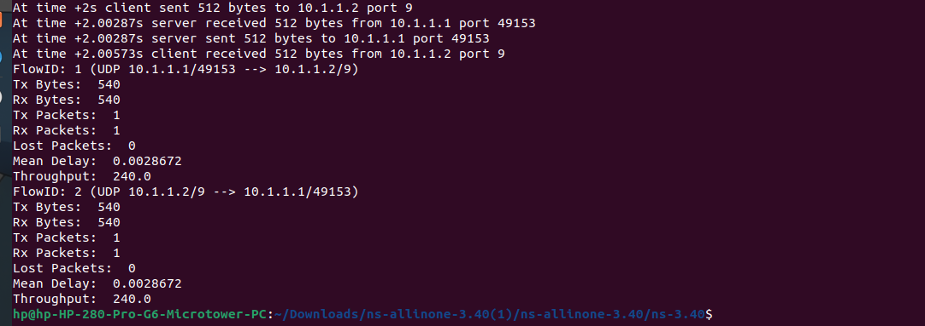

Packet Size- 1024:

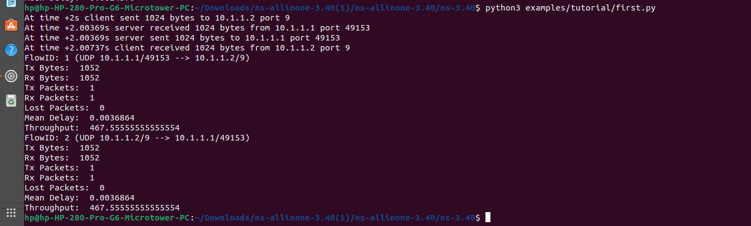

Packet Size- 2048:

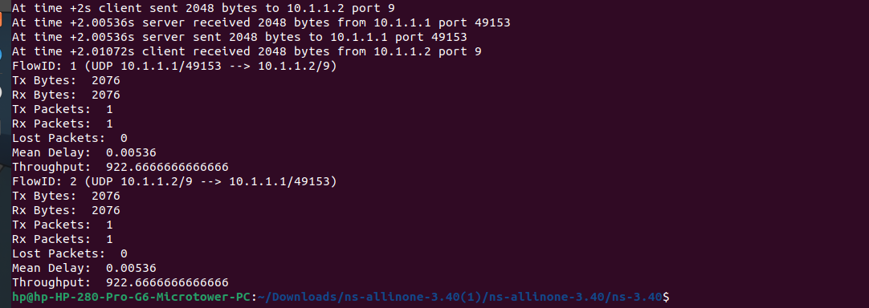

Throughput Vs Data size graph:

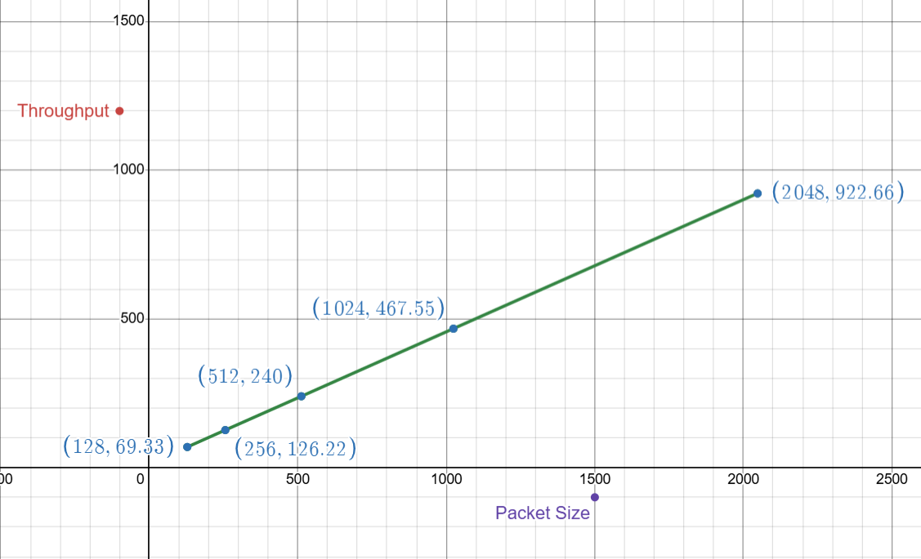

From the graph we can observe a linear relationship between throughput and packet size. As the size of the packet increases, the amount of throughput increases proportionally. So, the size of the packet is directly proportional to throughput.

